**Name:** Caroline Dixon **Date:** 3/28/2022 **Max points:** 25

**Lab section:** Monday

**Show your work!!!**

**Acquire**

Week: 12

Date: n/a Year: **2016** Data:

**Source Article/Visualization:**

“What the Most Profitable Companies Make Per Second” <https://www.titlemax.com/discovery-center/money-finance/most-profitable-companies/>

<https://www.makeovermonday.co.uk/data/data-sets-2018/>

**Represent**

**Critique**

I do like the visual flow of this visualization – it very nicely leads the viewer to read through the whole image and fits the title and content in a very nice circular pattern around the center, which also serves the theme of the visualization of “one second” very nicely. As for criticisms, the colors chosen for the different types of company are rather drab or desaturated when compared with the clean blue-gray background, and the image is far too cluttered to make any information stand out.

Critique the visualization: what do you like about it, dislike about it, what do you plan to do differently? Remove this text and highlighting before submitting your work.

Based on your knowledge of the Periodic Table of Visualization Methods (discussed in class this week), discuss which one of the 6 categories does the visualization you provided in the Represent stage falls in. Identify the method most closely related to the visualization in the Represent Stage and discuss the characteristics: overview, detail, detail AND overview, divergent thinking, convergent thinking. Refer to Week 10 Readings to assist with categorizing the visualization.

**Mine**

Main Question: What companies make the most amount of money on a per second basis (as of 2016)?  
Is there a correlation between Fortune 500 ratings and the amount of money made per second in 2016?

**Filter**

**Filtering not needed – data already streamlined**

**Stakeholders**

* Who is your audience? What assumptions did you make? What visualization tool/software did you use?
* My audience is people interested in the statistics surrounding the Fortune 500 companies mainly, though learning about powerful companies does appeal to those seeking to create a powerful company
* The assumptions I made were that the viewer would know what a Fortune 500 ranking was and that they would care more overall if it was about yearly income rather than income per second.
* I used Tableau because it is overall easier to do a bubble chart on Tableau than Excel.

**What to submit:** This document in PDF format only (if you do not know how to do this, see Lab 0 Exercise 1). Save this document as: LastnameFirstInitial_CGT270S22_MakeoverMonday#2.pdf

**Choose the best layout** for your makeover visualization: Portrait or Landscape, Remove the page of the layout that you DO NOT choose. No blank pages

**NEW Sketch your Makeover**

In the space below, sketch out your ideas for refined visualization. You must use pen/pencil and paper to sketch out your idea, then take a photo of your sketch and include it in the space below.

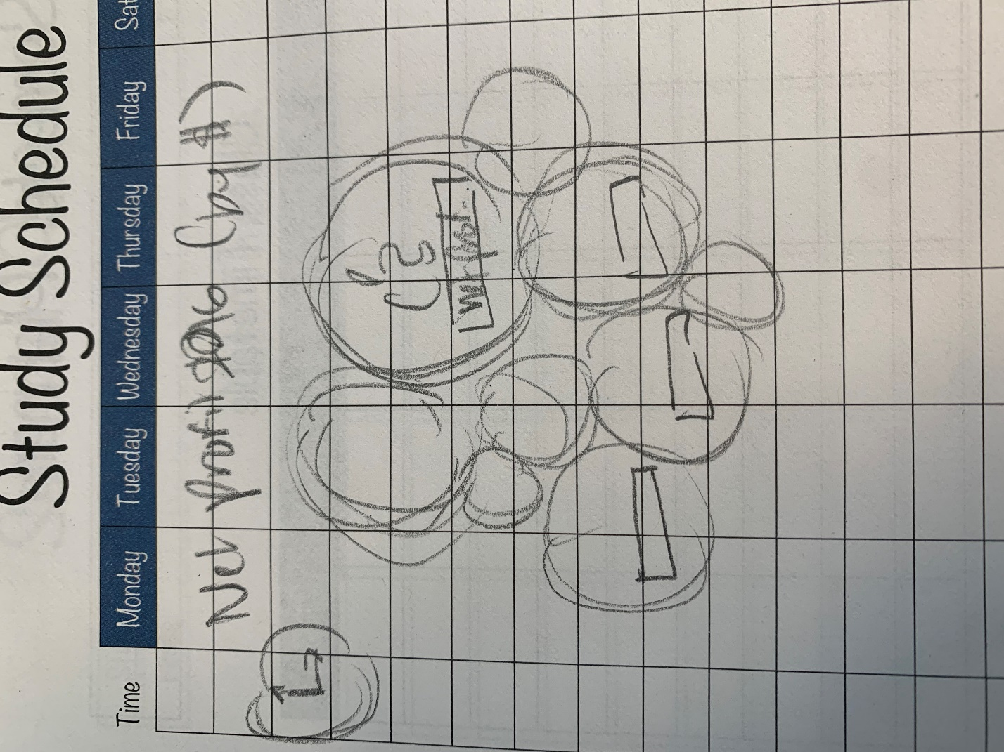

**Refine (Makeover – Portrait View)**

In the space below, show the computer-generated version of your sketch using the visualization tool of your choice. DO NOT draw what you sketched. The visualization should be created with the visualization tool (Tableau, Excel, Power BI, etc., of your choosing). Remember, the purpose of visualization is *“insight.”* Take and include a screenshot of your visualization and include it below. Use Data Visualization Best Practices (see data visualization checklist). You MUST use more advanced chart types for your makeover. **Chart types that are not allowed: bar (single or stacked), pie, line charts, scatter plots, no tables.**

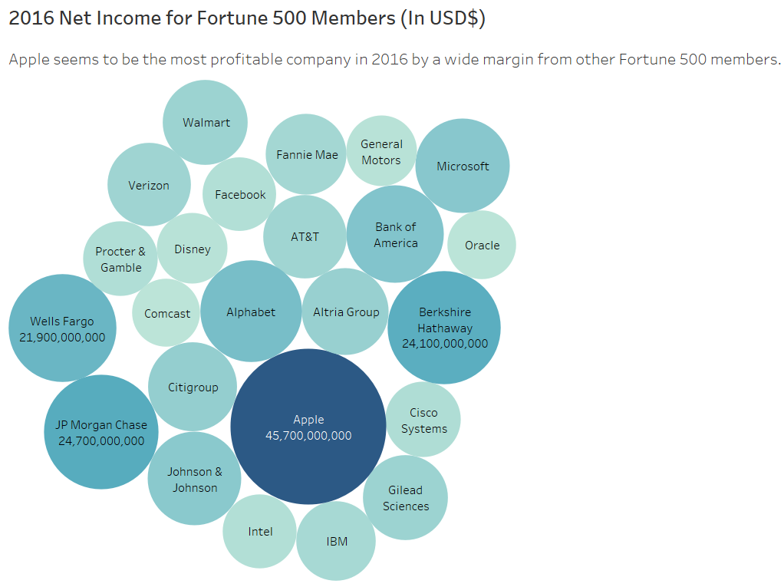

Figure Caption. Bubble chart representing the net income of Fortune 500 companies in 2016

**Resources**

Data Visualization Checklist:

<http://stephanieevergreen.com/wp-content/uploads/2016/10/DataVizChecklist_May2016.pdf>

How to give constructive criticism:

<https://personalexcellence.co/blog/constructive-criticism/>

Sample Makeovers

<https://www.makeovermonday.co.uk/gallery/>

**Grading Rubric**

|  |  |  |  |
| --- | --- | --- | --- |
| **Excellent** | **Good** | **Fair** | **Needs Improvement** |
| Meets **ALL** or most of these: Makeover is esthetically pleasing (color, perception), best practices followed (insightful), Correct dataset downloaded; provided an interesting point of view of the data; critiqued previous makeover, critique is constructive (indicates one thing that is done well, and one thing that could be done differently, what will be done to improve the visualization), assumptions (more than one) are listed.  [15 pts] | Meets **MOST** of these: Makeover is esthetically pleasing (color, perception), best practices followed (insightful), Correct dataset downloaded; provided an interesting point of view of the data; critiqued previous makeover, critique is constructive (indicates one thing that is done well, and one thing that could be done differently, what will be done to improve the visualization), assumptions (more than one) are listed.  [10 – 14 pts] | Consistently meets **SOME** of these: Makeover is esthetically pleasing (color, perception), best practices followed (insightful), Correct dataset downloaded; provided an interesting point of view of the data; critiqued previous makeover, critique is constructive (indicates one thing that is done well, and one thing that could be done differently, what will be done to improve the visualization), assumptions (more than one) are listed.  [5 – 9 pts] | Little to no evidence of the understanding of the data visualization process.  Lackluster makeover or no makeover.  Little effort.  [0 – 4 pts] |
| Sketch included: hand drawn, data vis best practices evident.  [5 pts] | Sketch included: hand drawn, lacking data vis best practices.  [3 pts] | Sketch included, but was generated by computer  [2 pts] | No sketch included.  [0 pts] |
| More advanced chart types used  [5 pts] | More advanced chart types used, followed most best practices  [3 pts] | Basic chat types used in the makeover  [2 pts] | Little to no improvement in visual representation of the data [0 pts] |